Nethermains Primary School Standards and Quality Report
Session: 2024–2025
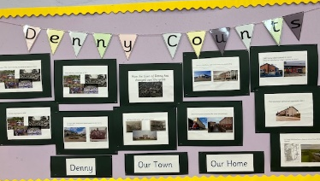

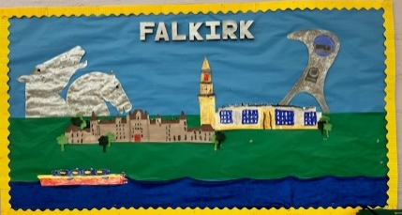

Introduction
This session has been a very positive year for our school, marked by significant achievements and progress across all areas of learning, wellbeing, and school ethos. Our pupils, staff, and wider school community have continued to work collaboratively to ensure that every child experiences success in a nurturing, inclusive, and stimulating environment.

1. Inspection and External Validation
In February 2025, we welcomed HM Inspectors of Education (HMIE) for an inspection. We are delighted to report that the inspection was extremely positive, with inspectors commending our inclusive ethos, high-quality learning and teaching, and the nurturing relationships evident throughout the school. The inspection highlighted the commitment of our staff team to continuous improvement and our focus on meeting the needs of every learner.

2. Nurture and Inclusion
This year, our commitment to The Promise and the principles of nurture and inclusion were formally recognised when we were awarded The Promise Award status. This achievement reflects the work we have undertaken to ensure that every child feels safe, supported, and respected. We continue to embed nurture principles across our school, ensuring that children's wellbeing remains central to all we do.

3. Rights Respecting Schools
We are proud to have achieved Silver Accreditation from Rights Respecting Schools. This is a significant milestone that recognises the work we have done to promote children’s rights across the school. Pupils are developing a strong understanding of their rights and responsibilities, and this has had a clear impact on our school culture, with learners taking increased ownership of their learning and school community.

4. Learning, Teaching and Achievement
Our pupils have continued to flourish both in and out of the classroom:
- Differentiation and Assessment: A key focus this year has been on enhancing differentiation to better meet the needs of all learners. Staff have worked collaboratively to ensure that learning experiences are accessible, challenging, and tailored to individual needs.
- To support this, we have taken significant steps to streamline planning and assessment processes, allowing teachers to more effectively monitor progress and respond to the diverse needs within their classrooms. This approach is helping to ensure that all pupils are appropriately supported and stretched in their learning. This is an improvement priority we will continue in academic session 25-26.
- Primary 5 Writing Project: Primary 5 pupils participated in an exciting writing initiative this year. Their stories and poems were compiled into a professionally bound book, which was celebrated with great pride by pupils and staff. This project not only enhanced writing skills but also boosted confidence and fostered creativity.
- Primary 6 Enterprise Group: Our Primary 6 pupils led a very successful enterprise initiative focusing on the World of Work. The group took full responsibility for designing, producing, marketing, and selling a range of items to the wider school community. Their project allowed all pupils across the school to participate by purchasing items at a fair cost, while learning key skills in budgeting, communication, teamwork, and entrepreneurship. The initiative was highly engaging and offered a real-life context for learning, empowering our learners to be active contributors.
- Primary 7 Residential Trip: Our Primary 7 pupils enjoyed a memorable and fulfilling residential trip to Lockerbie Manor. The experience promoted teamwork, resilience, and independence, and will undoubtedly leave lasting memories for all involved. Pupils embraced the wide range of outdoor activities and benefitted from the social and emotional growth the trip fostered.
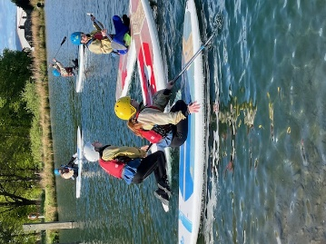
- Primary 1–6 School Trips: To support our curriculum and provide enriching real-life learning experiences, pupils from Primary 1 to 6 participated in an engaging educational trip to Briarland Farm and the Safari Park. These visits offered excellent opportunities to explore learning linked to science, sustainability, and social studies, while also enhancing learners’ curiosity and wonder about the natural world.
- Nethermains Has Talent Show: One of the highlights of the year was our Nethermains Has Talent Show, held in May. This whole-school event celebrated the diverse talents of our pupils, with children from across all stages taking part. Acts included singing, dancing, joke-telling, pipe band drumming, karate demonstrations, and more. The event showcased our pupils' creativity and confidence and was met with great enthusiasm from the school community. It was a joyful celebration of individuality and self-expression and highlighted the supportive and encouraging ethos that runs through our school.
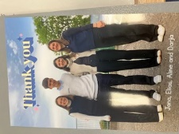
- Visitors from Switzerland: We were delighted to welcome four students from Switzerland into our school this June for a three-week visit. During their time with us, they gained valuable insight into Scottish education and fully immersed themselves in school life. The students thoroughly enjoyed being part of our classes and getting to know our children, who in turn loved having them here. A heartfelt thank you to each of them for their enthusiasm, dedication, and the positive contribution they made to our school community.

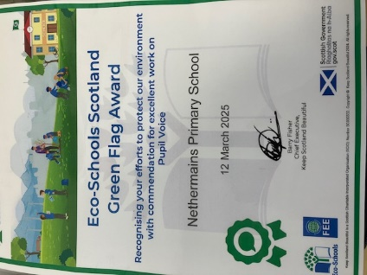
- At Nethermains, we are proud to care for our planet.
We recognise that there is no Planet B, and we are committed to supporting and protecting our environment for future generations. We were therefore delighted to receive our 8th Green Eco Flag—a reflection of our ongoing dedication to sustainability. A particular highlight of the award was the recognition of our children’s voice in driving eco-initiatives forward, which was celebrated as a real strength.

- Our after-school clubs have been a great success this year.
Thanks to PEF funding, we’ve been able to offer a wide range of clubs across the school, including golf, karate, tae kwon do, tennis, basketball, and football. These clubs have been very well attended and are provided free of charge to all participants. This initiative has given our children valuable opportunities to build friendships and positive relationships, while also developing new skills in a fun and supportive environment.
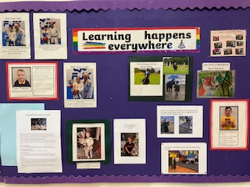
- We recognise that many of our pupils achieve success in activities outside of school as well. These achievements are proudly celebrated on our "Learning Happens Everywhere" wall, helping us promote the importance of learning and growth in all areas of life.

- Our small but dedicated Parent Council has once again shown outstanding support for our school and children in numerous ways. They generously contributed £10 towards each child’s school trip, reducing the cost for parents and carers to just £5. In addition, they kindly purchased hoodies for every Primary 7 pupil. Throughout the year, they also organise a variety of enriching experiences that benefit all our children.

5. Looking Ahead
As we look forward to the next school session, we remain committed to building on this year’s successes. Our priorities will continue to focus on ensuring equity, excellence, and inclusion for all learners, deepening our rights-based practice, and continuing to strengthen our family and community partnerships. We will also continue to refine our approaches to differentiation and planning, ensuring all learners receive high-quality, personalised learning experiences. We are actively addressing the recommendations from our recent HMIE inspection as part of our commitment to continuous improvement. This work is already underway and will continue throughout session 2025–26 and beyond.

Main Priorities for academic session 2025-2026 - School
- Effective planning in numeracy to support differentiation ensuring equity.
- Continue to raise attainment in Literacy across the school
- Improved attendance
- We are committed to fostering a school environment where positive, inclusive relationships form the foundation of every aspect of school life. This includes not only the interactions among students and staff but also our partnerships with parents, carers and the wider community." ​

Main Priorities for academic session 2025-2026 – ELC
- Stronger Early Numeracy Foundations​ by embedding number learning in real-life play and routines
- To continue to create an inclusive, nurturing environment where every child with Additional Support Needs is supported to achieve their full potential through tailored support, inclusive practices, and strong partnerships. To support all staff and families to understand ASN across the setting. ​

Working with our cluster colleagues

- Our cluster focus with our colleagues in Denny High School, Dunipace, Denny, Head of Muir, Antonine, Bankier and Bonnybridge Primary Schools will be focused around raising attainment in Literacy with a specific focus on reducing barriers for children on the Dyslexia Pathway in P7. ​
We would like to thank our pupils, staff, families, all colleagues across Falkirk Council and our partners for their ongoing support, resilience, and collaboration in making Nethermains Primary School a place where every child is nurtured, included, and inspired to achieve.
Grace Law Head Teacher
June 2025

